The problem for Edward III was not that he lacked a male heir, but that he had so many - and therefore rivals for the throne.

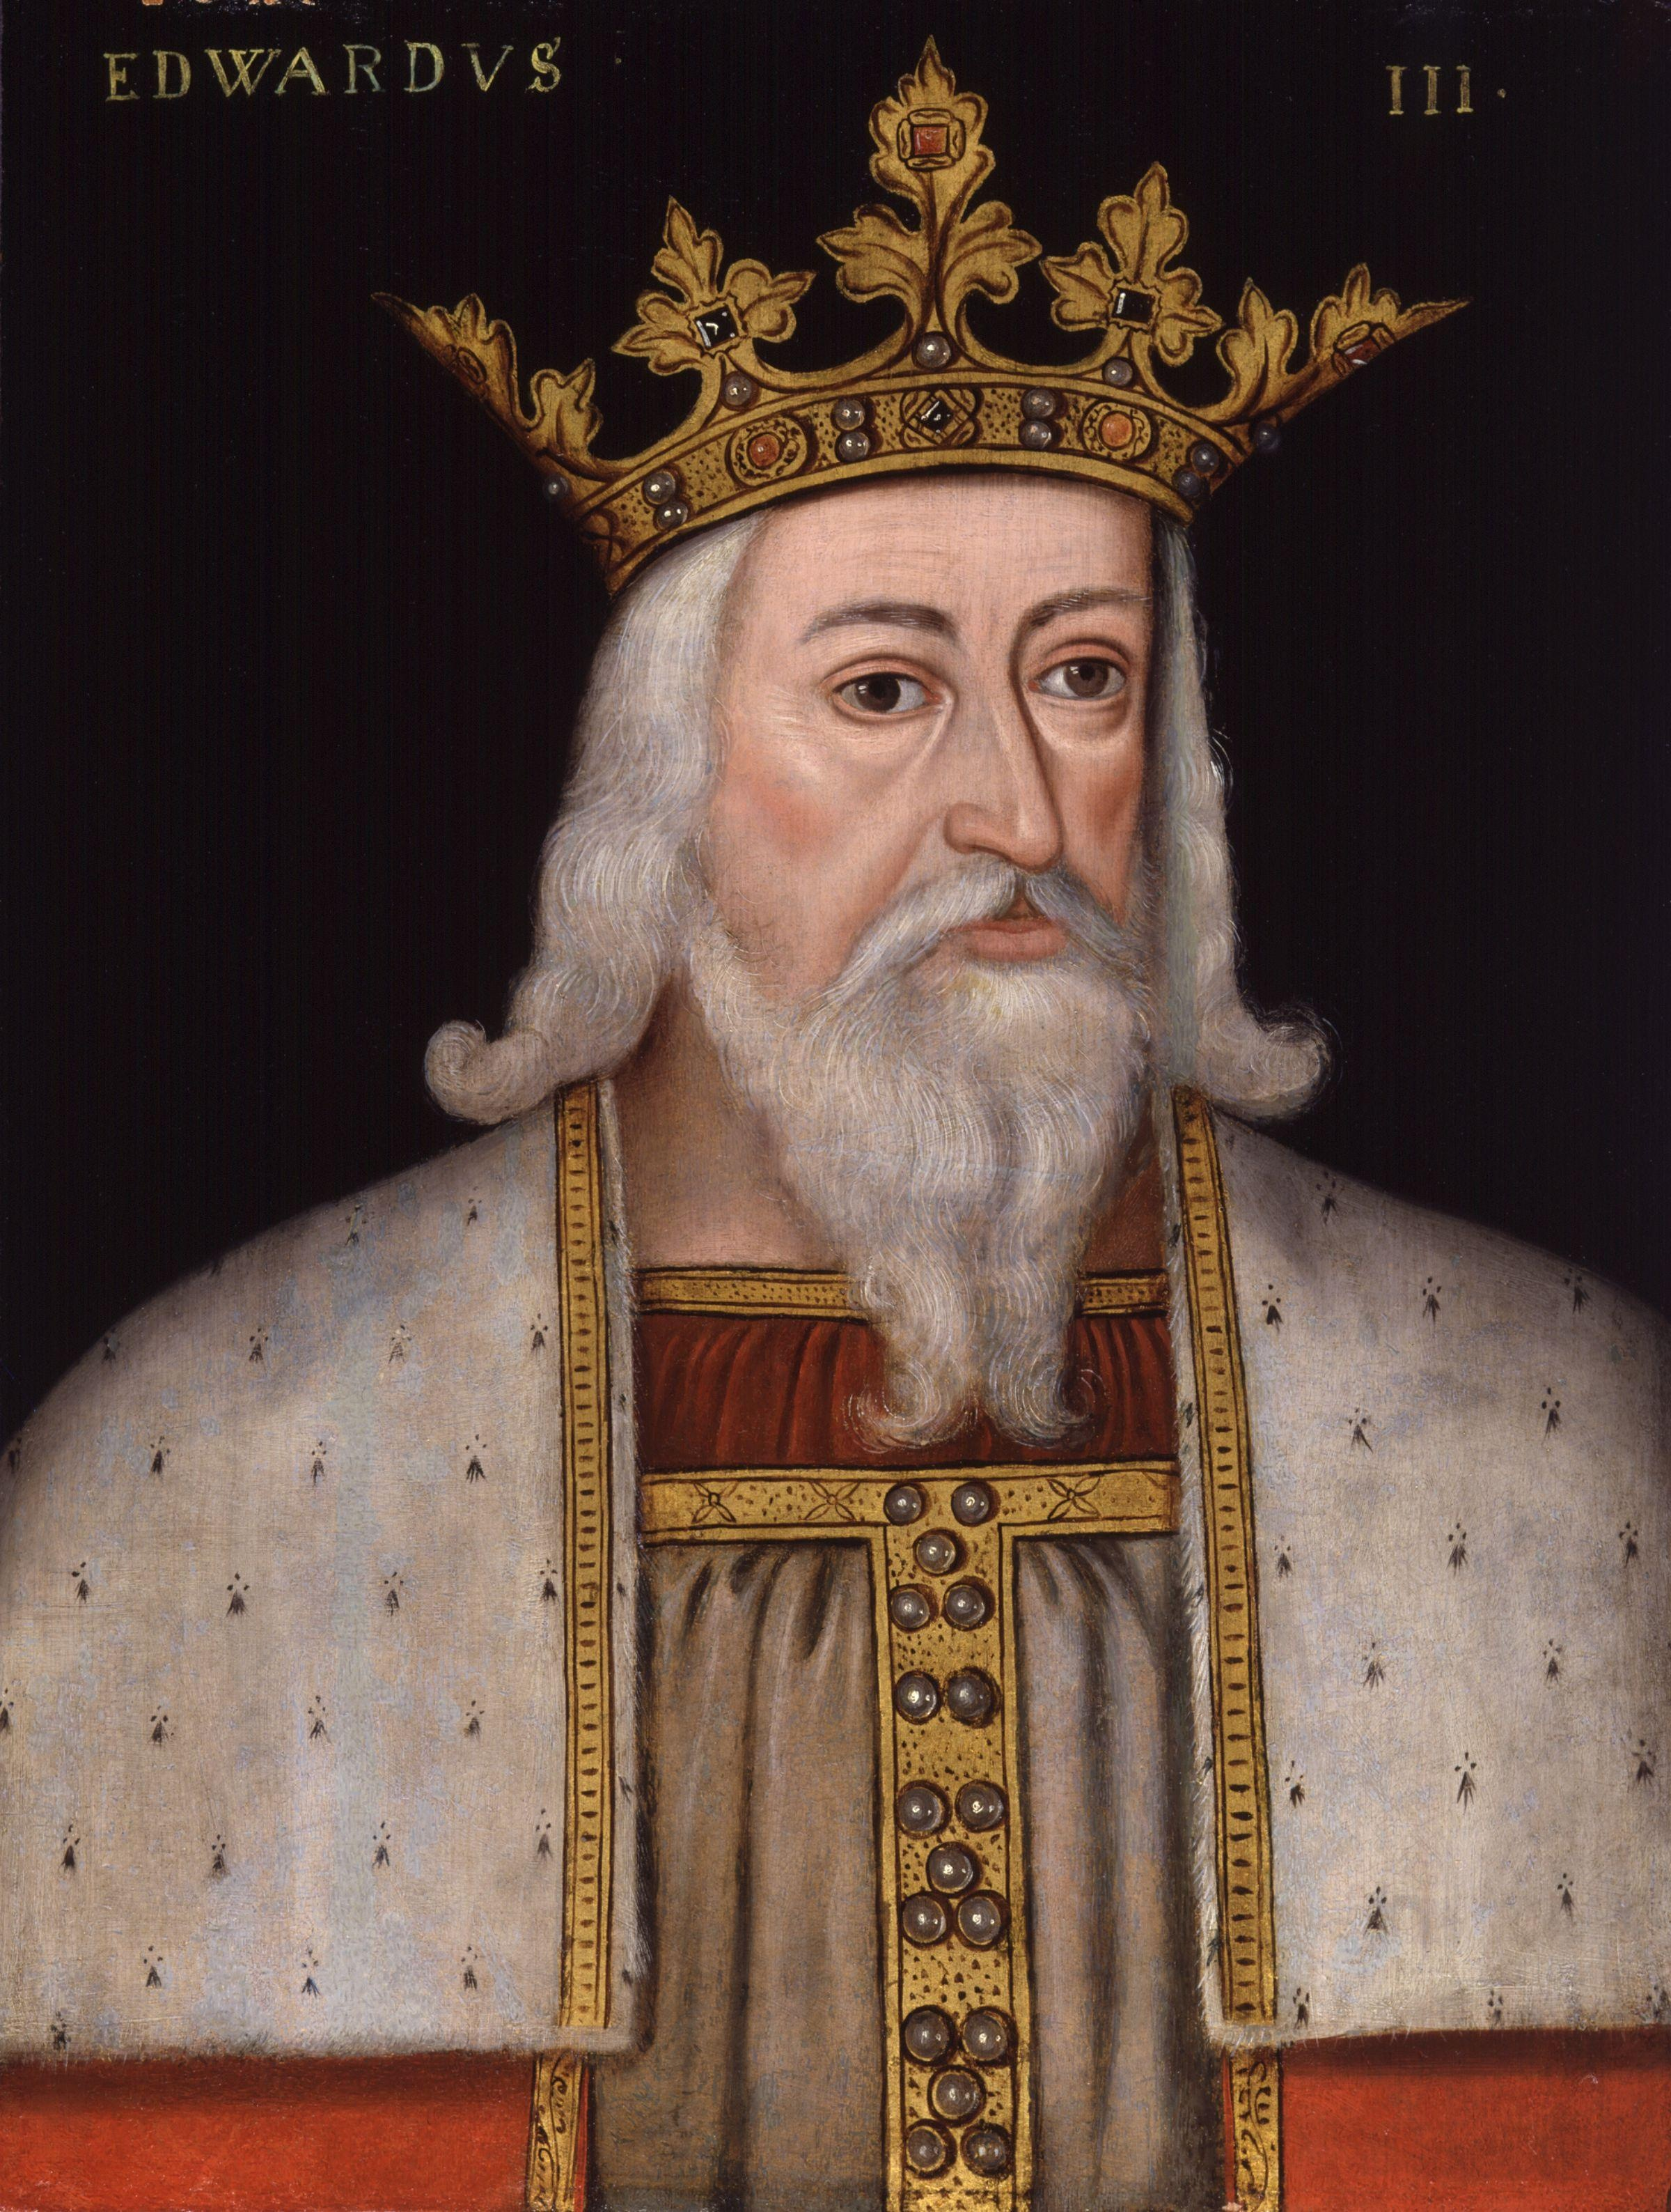
Key to the Yorkist and Lancastrian lines
- Edward the Black Prince, was his first son and designated heir, but he died a year before his father.
- John of Gaunt, Duke of Lancaster - and head of what would become the Lancastrian line - a line that was complicated by the fact that John of Gaunt had three marriages –
  - the first with Blanche of Lancaster from which Henry IV (Bolingbroke) the main Lancastrian line was descended;
  - a second with the Infanta Constanze of Castille - a political marriage that produced one daughter;
  - and a third wife Catherine Swynford, whose offspring were all born whilst Catherine was his mistress. They were declared legitimate upon marriage by King Richard II on the understanding that neither they nor their descendants could inherit the throne of England. This line became known as ‘Beaufort’
- Edmund, Duke of York - the head of what would become the Yorkist line

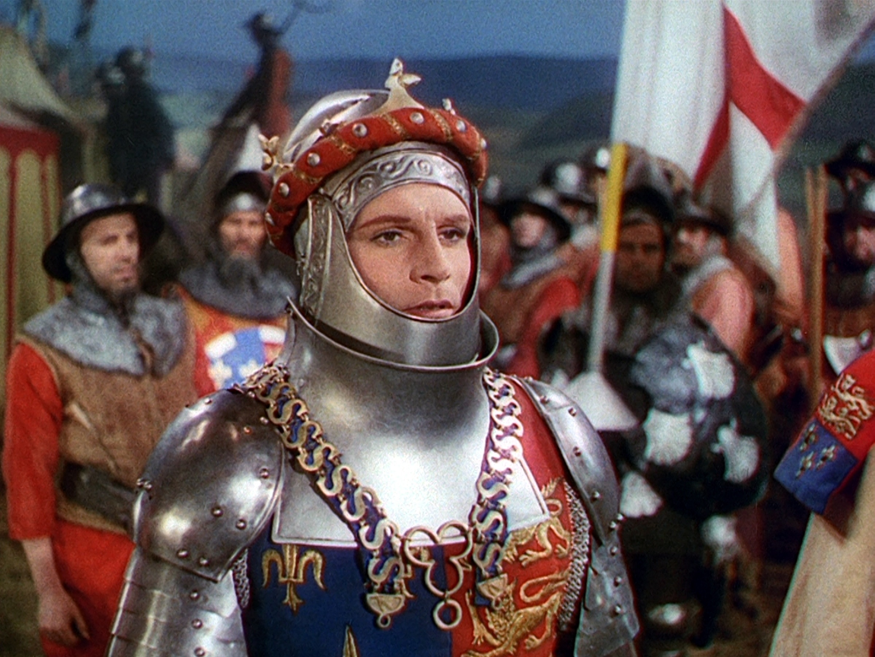
The Wars of the Roses
The death of the Black Prince, Edward, meant that the throne passed to his son, Richard II at the age of 10 in 1377. England was in fact ruled by a council of aristocrats during the early years of his reign and reflects the growing power of the aristocracy.

Richard was deposed and the throne usurped by Henry Bolingbroke (who became Henry IV), son of John of Gaunt who had been disinherited by the increasingly unpopular Richard II. So from 1399, England was ruled by the second line and Richard II died in captivity.

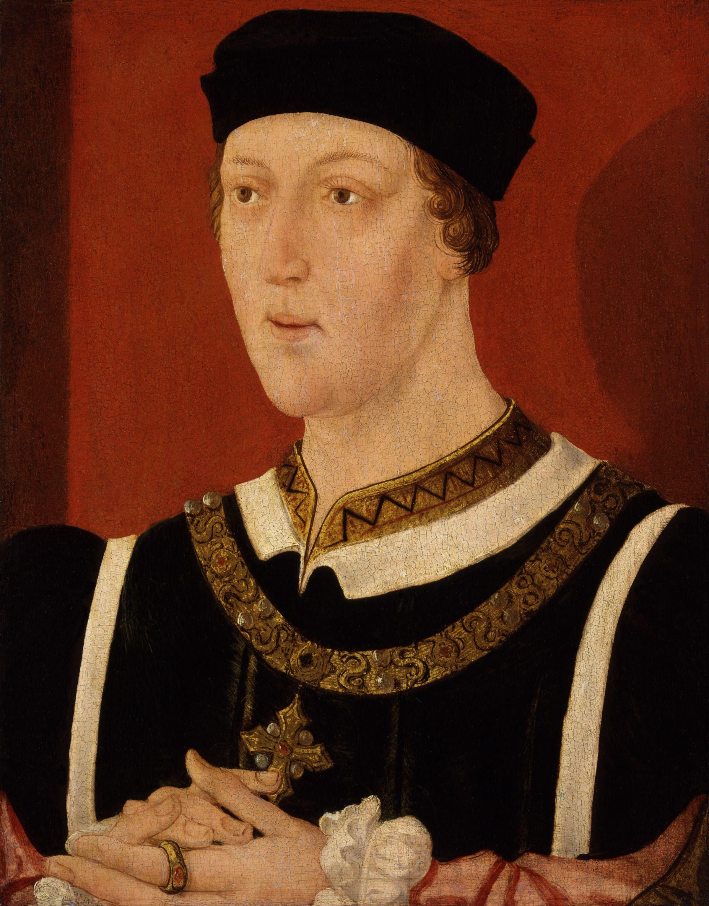
The Lancastrian line lacked legitimacy - but this was compensated for by Henry V’s military prowess and victory at Agincourt in 1415, followed by the Treaty of Troyes of 1420 designating Henry as heir to the throne of France. However, Henry V died only 2 years later, leaving the throne to another child, Henry VI. Again, England was ruled by regents until 1437. It was from this point, however, that a series of military defeats in France completely undermined his credibility among the aristocracy. England lost the hundred years war with France by 1450 when Normandy was lost, and in 1451 England lost Gascony. A final defeat in 1453 saw Bordeaux permanently returned to French rule, leaving nothing left of the former English territories bar the port of Calais. The war was effectively over though it would not officially end for many years yet. The loss of territories meant a loss of revenues and wealth for the aristocracy and Henry VI was blamed for the defeat. Lacking legitimacy in the first place, Henry VI was undermined by these defeats and suffered a mental breakdown during which time he suffered rebellion led by Jack Cade in 1450. During this period Henry VI was increasingly dependent upon the duke of Somerset, descendent of the Beaufort family.

Richard, Duke of York (son of Edmund, son of Edward III) was worried that Henry VI was going to name Beaufort his successor. Considering himself and his line as carrying more legitimacy, Richard began to press its claims to the throne, leading eventually to a series of bloody battles, and eventually to the Yorkist victory at Towton in 1461, where 28,000 were killed in a single day - most of them Lancastrians - and Richard’s son usurped the throne as Edward IV.

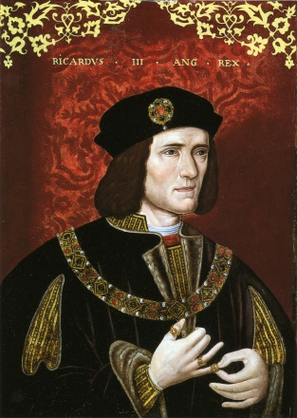
Edward IV’s would have been a success but for his poor choice of wife, Elizabeth Woodville, whom he married for love rather than for land, political or economic benefits. The rise of the Woodvilles alienated Edward IV’s most important aristocratic supporters - particularly the Earl of Warwick, alienated his chief aristocratic supporter - the Earl of Warwick who eventually turned against Edward and supported the re-adeption of Henry VI in 1470. Edward IV, however, returned to the throne after decisive victory’s at Barnet in 1470 (where the Earl of Warwick was killed) and the Battle of Tewkesbury in 1471 where both Henry VI and his son, Edward were both killed.

This should perhaps have been an end to the Lancastrian claim but for fact that Edward died in 1483 leaving yet again a child to inherit the throne - as Edward V who was usurped not by a Lancastrian claimant, but by his uncle Richard of Gloucester who persuaded parliament to pass Titulus Regius which declared Edward IV’s marriage to Elizabeth Woodville illegal, thereby giving him a stronger claim to the throne than his nephew. Richard became King as Richard III in 1483. Edward and his brother Richard were placed in the Tower of London where they are thought to have been assassinated under Richard’s orders. This has never been proven, but it is significant that Edward’s widow, Elizabeth Woodville, now supported Henry Tudor’s claims to the throne - thus switching sides from the Yorkist to the Lancastrian line. Henry Tudor agreed to marry her daughter, Elizabeth of York, in return.

Background to the Tudor claim.
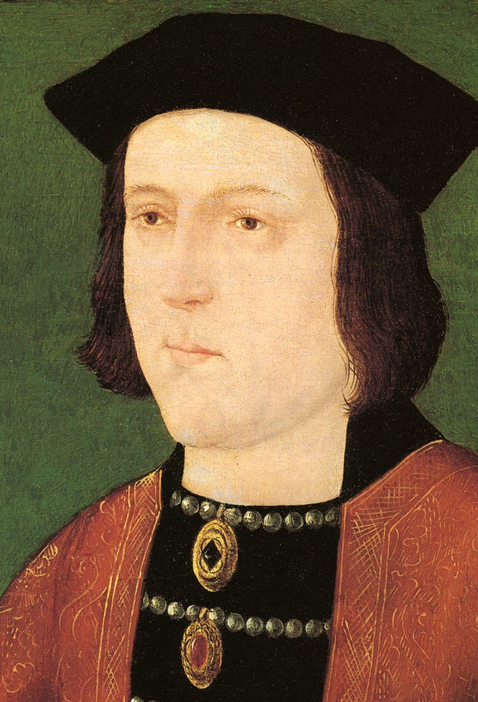
Arguably, the Tudor claim to the throne has its origins in Owen Tudor’s marriage to the widow of Henry V, but this seems unlikely. The real claim to the throne - not a strong one - lay in the fact that Owen’s son, Edmund married Margaret Beaufort (see the key to the Yorkist and Lancastrian lines). Henry Tudor therefore had a claim to the English throne but which was weak to say the least. Firstly, his claim was through the female, not the male line. Secondly, the Beauforts were only legitimized on the premiss that neither they nor their descendants could ever claim the throne of England. Thirdly, Henry was Welsh!

Even if we set aside the weakness of Henry’s claim, there were other reasons for thinking that his chances of success were really not good in 1485:
He had been a refugee for 14 years; he had no land, money, training or experience, no connections with the leading members of the English aristocracy. Finally, his expedition to England in pursuit of the crown in 1485 was funded by the French crown.

Battle of Bosworth and the establishment of the Tudor monarchy
Henry Tudor’s victory at the Battle of Bosworth was no foregone conclusion and was perhaps only brought about by the actions of Richard III’s key aristocratic supporters, Sir William and Sr Thomas Stanley who switched sides, and Henry Percy, fourth Earl of Northumberland, who did not engage. The death of John Howard, Duke of Norfolk, depolarised Richard and his supporters and promoted Richard into an impromptu cavalry charge deep into enemy ranks which resulted in his death.

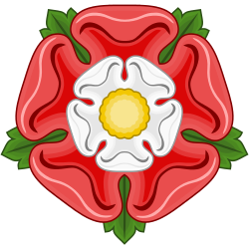
Henry’s actions reveal an insightful politician. Henry proclaimed himself king at the battle itself - he did not wait on parliament. He strengthened his claim to the throne by marrying Elizabeth of York, daughter of Edward IV and Elizabeth Wodeville, but only 3 months AFTER he had himself made king. In other words, Henry wanted to make clear that his kingship did not depend upon this marriage, and that this was NOT the basis of his claim to the throne, but that it nonetheless strengthened that claim by uniting the Lancastrian and Yorkist houses. Again, only AFTER he married Elizabeth did he get Parliament to repeal Titulus Regius, re-legitimizing the offspring of Edward IV and Elizabeth Woodville. The Tudor taste for propaganda that would be seen in Henry VIII’s taste for ostentatious chivalric tournaments (e.g. Field of Cloth of Gold, 1520) is already present in his father’s adoption of the Tudor Rose – symbolizing his unification of Yorkist and Lancastrian lines through his marriage with Elizabeth of York.

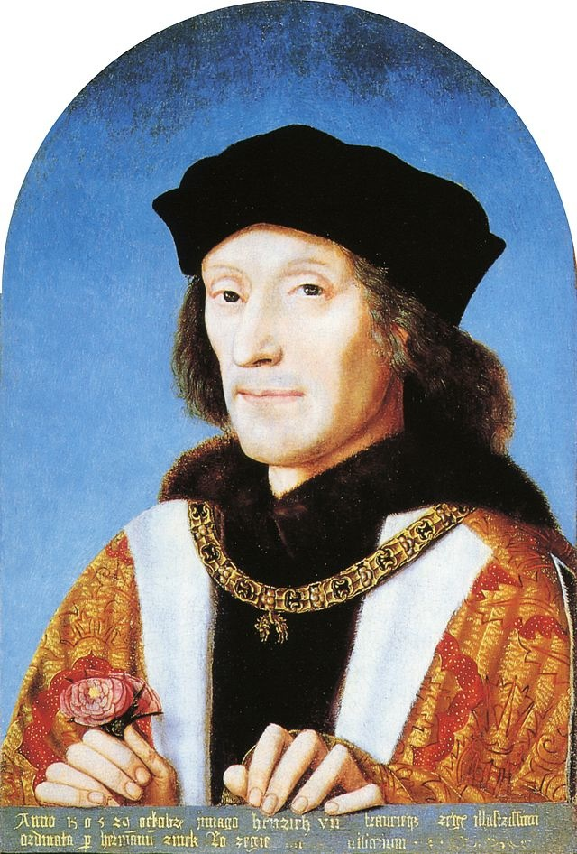
Advantages enjoyed by Henry VII over his predecessors
Despite the weaknesses of Henry’s claim to the throne and his own lack of fitness, he did have a number of advantages that are important for understanding the Tudor monarchy. Firstly, he did not have familial rivals as Edward IV had (George Plantagenet, Duke of Clarence, and Richard of Gloucester were both to prove treacherous to Edward IV and his offspring). Henry VII’s only potential familial rival was his uncle Jasper Tudor who remained a staunch supporter and died childless. The Tudor line was therefore uncomplicated. Secondly, during the 1490s the French were preoccupied with war in Italy, meaning they did not interfere in his reign as they had in that of Richard III. Thirdly, the previous bloody battles in the Wars of the Roses had decimated the English aristocracy, and in particular, the landed estates of aristocrats killed in those battles reverted to the crown. Richard of Gloucester, for example, had taken over the lands of Richard Neville, Earl of Warwick, and following the Battle of Bosworth, Henry VII took those lands. Finally, through his own policies, including Acts of Attainder (disinheritance), the number of senior Aristocratic families in England was further reduced from 50 in 1485 to just 35 in 1509.

Henry VII’s Financial and Foreign Policies
The key to understanding Henry VII’s success as a monarch is the fact that he embraced the notion that the king should ‘live of his own’. This was about restoring royal finances by governing his estates and using his prerogative powers and avoiding raising taxation in parliament. The use of Bonds and Recognizes, which not only added to the royal purse but brought the aristocracy firmly under the crown’s control. Richard’s emphasis upon financial prudence (not to be confused with Gordon Brown’s emphasis on the same), restored annual revenue to £104,000, compared to just £65,000 in the last years of Edward IV, and just £24,000 in the reign of Henry VI. This was helped by the absence of foreign campaigns. Henry did not renounce England’s claims to French titles - this would have been political suicide - but nor did he pursue them, thus avoiding enormous expense and the need to raise taxes in parliament.

Continuing Yorkist claims - the sisters of Edward IV, Elizabeth of York and Margaret of Burgundy and the de la Poles
However, it would be a mistake to think that Henry’s reign was all plain sailing. First of all he faced two fairly serious rebellions. The Battle of Bosworth is usually held up as the final battle in the Wars of the Roses, but Henry had to defeat Yorkist forces at Stoke again in 1487, which rose in support of Lambert Simnel who pretended to be the Earl of Warwick, son of the Duke of Clarence, Edward IV’s brother. He was really the puppet of John de la Pole, son of John and Elizabeth of York (sister of Edward IV). Since Henry already had the real Earl of Warwick in the Tower, there was no doubt about the pretense! Following the defeat of the Yorkist forces at Stoke, and realizing that Simnel was merely the puppet of adults, had the young lad employed as a spit-turner in his kitchens! A more serious rebellion arose in Ireland, when a new pretender, Perkin Warbeck, claimed to be Richard of York (one of the princes in the tower) and was proclaimed king. Funded by Edward IV’s other sister, Margaret of Burgundy, He landed in Kent in 1495 where his forces were routed, and again in Cornwall in 1497 when, following another military disaster, he was eventually hanged. More important than either Simnel or Warbeck, however, was the persistence of the Yorkist claim, represented by the de la Poles.

Problems of Succession
Henry VII had several children - but this was no guarantee in itself of the future of the dynasty. First of all, Henry’s eldest son, Arthur, died in 1502, having formed a very advantageous marriage alliance through Catherine of Aragon. Within two years of Arthur’s death, Henry himself fell gravely ill and his remaining heir, Henry was still a child.

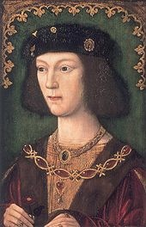
Henry VII renewed his efforts to seal a marital alliance between England and Spain, by offering his second son in marriage to Arthur's widow Catherine. Both Isabella of Castile and Henry VII were keen on the idea, which had arisen very shortly after Arthur's death. On 23 June 1503, a treaty was signed for their marriage, and they were betrothed two days later. A papal dispensation was only needed for the "impediment of public honesty" if the marriage had not been consummated as Catherine and her duenna (chaperone) claimed, but Henry VII and the Spanish ambassador set out instead to obtain a dispensation for "affinity", which took account of the possibility of consummation. The young Henry's age, only eleven, prevented cohabitation. Isabella's death in 1504, and the ensuing problems of succession in Castile complicated matters. Her father preferred her to stay in England, but Henry VII's relations with Ferdinand had deteriorated. Catherine was therefore left in limbo for some time, culminating in Prince Henry's rejection of the marriage as soon he was able, at the age of 14. Ferdinand's solution was to make his daughter ambassador, allowing her to stay in England indefinitely. Devout, she began to believe that it was God's will that she marry the prince despite his opposition.

Henry VII died on 22 April 1509, and the young Henry succeeded him as king, adopting the regnal name of Henry VIII. Soon after his father's burial on 10 May, Henry suddenly declared that he would indeed marry Catherine, leaving unresolved issues concerning the papal dispensation and a missing part of the dowry. The new king maintained that it had been his father's dying wish that he marry Catherine. Whether or not this was true, it was certainly convenient.

Questions
- Identify those monarchs that succeeded to the throne as children - what happened to them?
- What evidence is there that choice of marriage partner was important to the success of the monarch?
- Which monarchs were dethroned and/or killed during this period?
- Why was Henry Tudor’s claim to the throne weak?
- What other disadvantages did he have?
- In what sense did he have some advantages over his predecessors?
- How did Henry VII set about stabilizing England and restoring dignity to the throne and why did he succeed?
- Why do you think Henry VII chose the name ‘Arthur’ for his first born?
- Why was the issue of succession so significant during Henry VII’s reign?
- Almost as soon as Henry VIII succeeded to the throne he began planning campaigns in France. There were to be three such campaigns during the course of Henry’s reign, all of them enormously expensive - eventually bankrupting the throne - and almost completely fruitless. Can you account for Henry’s obsession?

